Retail Sales Analysis with Microsoft Excel

PART 1 — Data Understanding (10 Marks)
- There are 9 datasets provided.
- Customers: Information about registered customers and their demographics. Primary key is Customer_ID.
- Products: Product catalog; product name, category and sub, brand, all prices. Primary key is Product_ID.
- Orders: Sales and transactional data of orders like customers, products, pricing, quantity. Primary key is Order_ID. Possible foreign keys are Customer_ID, Product_ID and Store_ID.
- Stores: branch locations and the opening data. Primary key is Store_ID.
- Returns: track of returns like linking it to an original order, reason, refund date and amount refunded. Primary key is Return_ID. Possible foreign key is Order_ID
- Employees: HR database for employees’ details such as name, role, location, salary. Primary key is Employee_ID. Possible foreign key is Store_ID.
- Suppliers: Supplier information; name, contact details, location. Primary key is Supplier_ID.
- Inventory: Tracks stock levels per branch and the last restock date. Primary key is Inventory_ID. Possible foreign keys are Product_ID and Store_ID.
- Orders Items: Line breakdown of orders, each line representing a specific product within an order like quantity, price, discount and total. Primary key is Order_Item_ID. Possible foreign keys are Order_ID and Product_ID
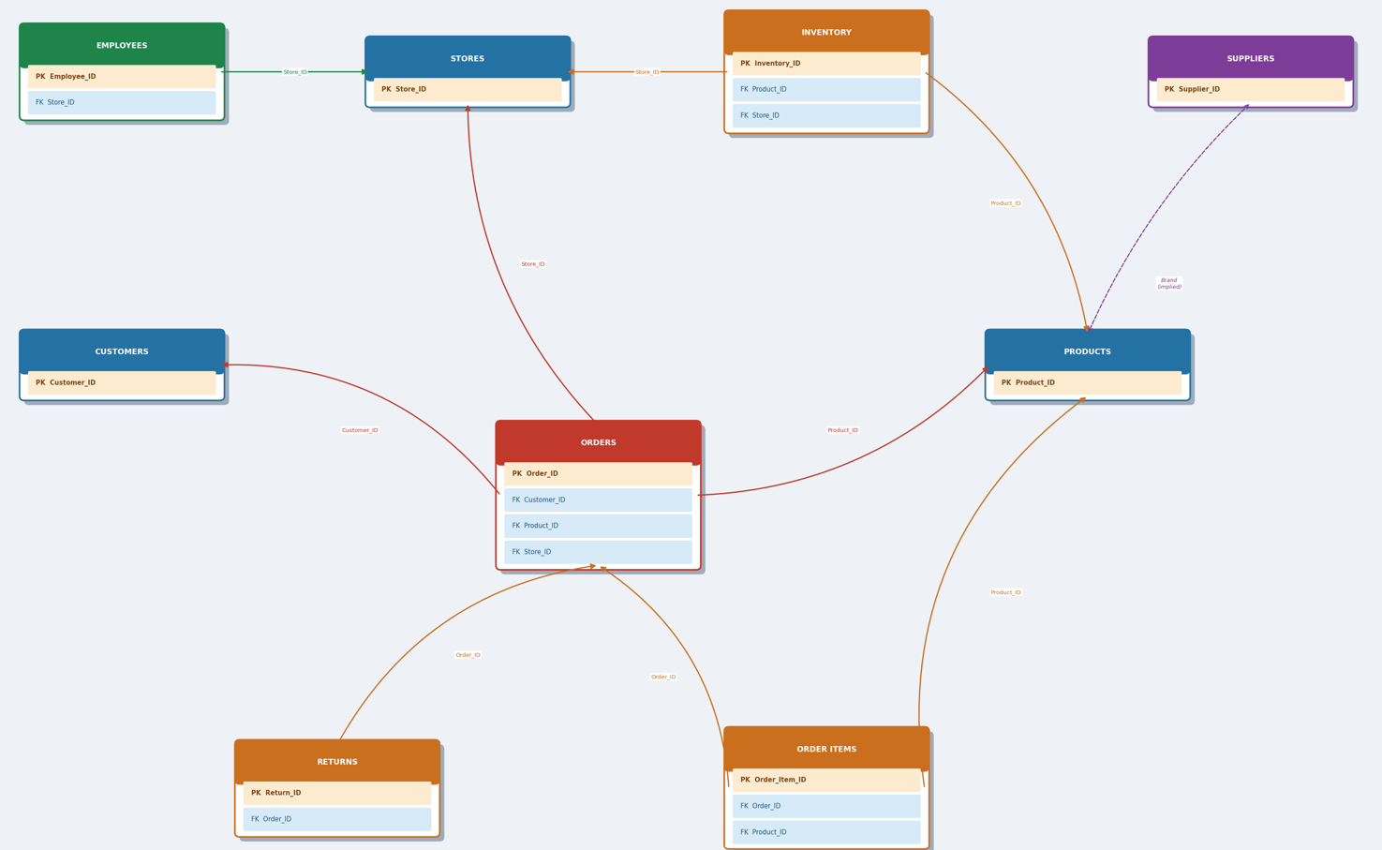
Part 8 – Business Questions
- The product with the highest revenue is Home item with a revenue of N21 638 851
- ShopSmart Lagos performed the best with 8097 orders and a revenue of N1 232 192 532
- Beauty sold the most, 11 809 orders, 35 196 units sold and a revenue of N1 762 500 500
- December 2025 generated the highest revenue of N660 629 527
- Joseph Smitn spent the most, 68 orders and N12 009 782
- Home items 263 with 11 returns
- Matthews and Sons Supplies, Rosales PLC Supplies, Smith PLC Supplies, Smith LLC Supplies, Dyer LLC Supplies, Williams Group Supplies, Garcia PLC Supplies, Myers and Sons Supplies, Thomas Ltd Supplies, Jones Group Supplies, Martinez Ltd Supplies – All tied for 2 products.
- ShopSmart Kano, ShopSmart Awka and ShopSmart Enugu.
- South region performed the best with a revenue of N2 424 534 663
- Electronics have low rreturns and a good revenue as well

Part 9 – Business Recommendations

Key Findings:
- Lagos, Ibadan and Abuja stores generate the most revenue of 48.5% and the bottom stores Kano, Awka and Enugu only generating 11.6%. Kano earns 4.2 times less compared to Lagos and the top stores moving almost 4 times units compared to the bottom stores, indicating underserve in their locations.
- Returns rate costs a lot of money in refunds, with beauty higher and specific products for Home. Late delivery, wrong item and damaged stock are all operational and supply chain related issues that need to be investigated.
- There is indeed fluctuations in revenue, February the weakest. Managements concern is confirmed

Business Recommendations
- Stock/Inventory must be balanced in stores. Increasing units at low unit stores could increase annual revenue as well but market research must be done at these locations to determine stock level.
- A quality control process must be implemented, improve delivery logistics and investigate product descriptions and barcode/SKUs to eliminate incorrect items delivered. There must be a focus on beauty category as well to investigate their high returns.
- Electronics seem to be promising in their margins, there is a growth potential and therefore an investment here is wise, and less over-investment in beauty and fashion.

Risk Identified
- Most of the revenue is only concentrated in 3 stores. Should anything happen at these stores, nearly half of the business’ revenue is at risk of failure or decrease.

Opportunity Identified
- As identified, February performed the worst. To close this gap, the company could work around promotions and events around February to increase sales and perhaps business exposure.

